**Timer Calibration Verification SOP**

**Background Information**

Timer calibration must be verified twice per year, after maintenance, malfunction or in accordance with manufacturer’s recommendations, whichever is most frequent.New timers must be verified before being used with a certified traceable stopwatch such as a National Institute of Standards and Technology (NIST) traceable stopwatch. Uncertified timing devices must be verified at the time of testing against a NIST traceable source.

**Purpose**

To ensure timers used in procedures are accurate when compared to a current certified traceable timer/stopwatch such as a National Institute of Standards and Technology (NIST) traceable stopwatch.

**Definitions**

1. NIST certified timer: a timer that has been verified as accurate from an outside, NIST certified source.
2. NIST verified timer: a timer that has been verified as accurate against a NIST in-house source (such as a website). This can be accomplished by following the procedure in Section A below.

**Pre-analytic Procedure**

1. This procedure applies to all laboratory timers including those timers that are included as parts of other instruments such as centrifuges.
2. Timers that are not verified using the procedure outlined in this SOP may be cleaned or serviced and retested. If a timer cannot be repaired, it should be discarded.
3. Calibration records should indicate dates of removal, return to service or if timer is discarded.
4. All calibration sheets should remain on file as a record, even after the timer has been removed permanently from service.
5. At time of calibration verification, timers should be inspected for readability, alarm quality, and cleaned.

**Analytic Procedure**

Supplies

1. NIST certified stopwatch/timer or uncertified timer to be validated against NIST traceable source.
2. Laboratory timer (referred to as Test), identified by a unique, assigned number.

Timer Calibration Verification Procedure

If using an Uncertified Timer, the timer will need to be verified first before testing other timers in the laboratory. Verify the timer by following the instructions outlined in Section A, and then use the verified timer to perform timer checks as outlined in Section B.

**Note**: Timers used at the bench are to be considered contaminated and should only be handled with gloves and other personal protective equipment and/or thoroughly disinfected before calibration verification.

A. Procedure for Verification of a Laboratory Timer Against NIST Traceable Website

1. Locate the official National Institute of Standards and Technology at NIST traceable website at <https://www.time.gov>. The bottom NIST clock on the right-hand side.

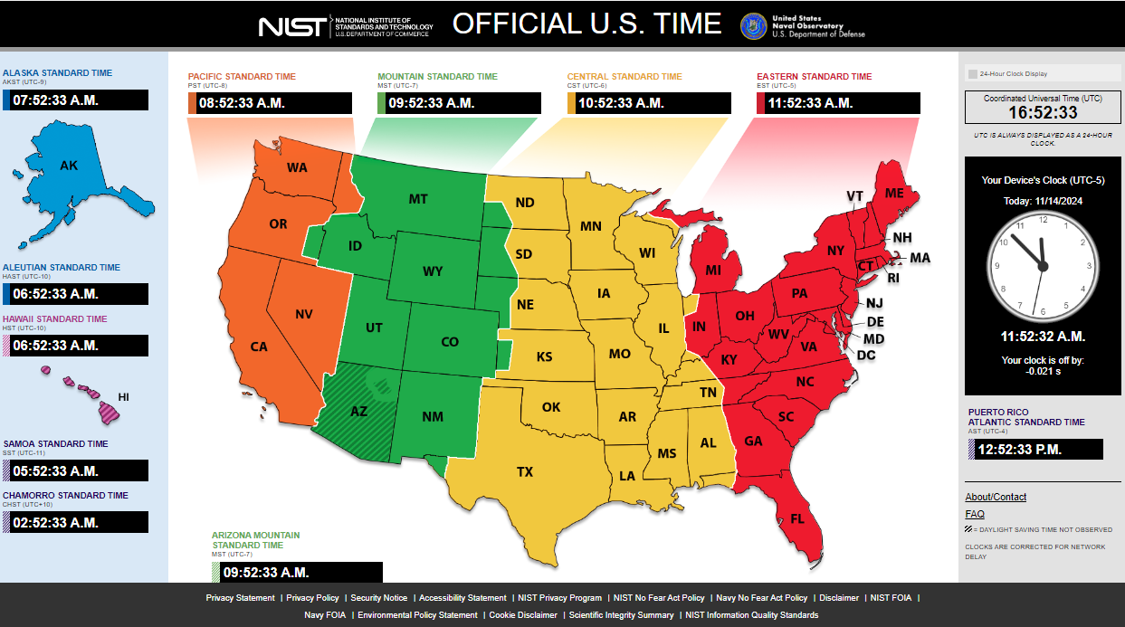

1. Please note that it is the time interval, not the actual time, that is important for the timer verification process.
2. Take the timer to be checked to the same location as the computer used to access the NIST website.
3. At the beginning of the hour start the laboratory timer that is being verified. Document the time for both the computer website and the timer that is being verified on the record sheet (see Appendix A - Timer Verification Record Sheet for Non-Certified Timer against NIST Traceable Source for an example worksheet).
4. At the end of the hour, go back to the computer and the timer that is being verified. As the computer clock reaches the end of the hour stop the timer. Record the ending time from the computer website and the time from the timing device.
5. Compare the times as indicted on the record sheet and indicate if the timing device being verified is within the defined acceptability limits.
6. If the verified timer is acceptable, label it with the date of verification and the initials of the laboratory staff member who performed the test.

Tolerance Limits for Verification of a Timer against NIST Traceable Source

The NIST verified timer should read one hour (60 Minutes) +/- 1 second at the end of the test time of one hour.

Once the timer has gone through the verification procedure and has passed, this timer can then be used to check other timers in the laboratory.

B. Equipment Calibration/Maintenance

1. Set the laboratory timer at a setting used in a procedure and start the Test Timer and the NIST certified or verified timer simultaneously.
2. Stop the NIST verified timer precisely as the timer being checked indicates that the set time has elapsed.
3. Record times from both the verified timer and the Test Timer on the log sheet (see Appendix B- Timer Calibration Verification Log for an example worksheet).
4. Calculate the difference between the two times and record. If there is a difference between the verified timer/stopwatch and the timer that is being checked, indicate whether the “Test Timer” difference is short or long with a minus or plus sign.
5. Assess the acceptability of the difference using the recommended criteria specified in the section below or by the manufacturer. If acceptable, label the timer with the date, the initials of the laboratory personnel performing the test, and the signed difference and proceed to step (9).
6. If the difference is NOT acceptable, repeat the process. If the setting on the timer can be adjusted to reliably achieve the correct timing, then mark the corrected setting with the verified time. Note the action on the log sheet.
7. If still NOT acceptable, remove the timer from use, record the failure on the log sheet, notify the supervisor and obtain an alternate, acceptable and uniquely numbered timer.
8. Ensure all fields of the log sheet are complete and filed. Note all actions taken on the log.
9. Repeat the process for all times called for in the testing procedures for which this timer is used.

Tolerance Limits for Timer Verification

Acceptable difference between the Test Timer and the Certified or Verified timer should be +/- 2% of the total Test Time or +/- 1 second at the end of one hour.

Refer to the manufacturer recommendations in accordance with testing procedure for additional tolerance limits.

**Post-analytic Procedure**

Archiving Results and Report Documents

1. Timer calibration records should indicate dates of removal, return to service or if timer is discarded.
2. All timer calibration verification records should remain on file, even after the timer has been removed permanently from service.

**References**

1. College of American Pathologists (CAP) 2021. Commission on Laboratory Accreditation, Laboratory Accreditation Program, Hematology and Coagulation Checklist
2. CLSI General Laboratory Equipment Performance Qualification, Use, and Maintenance. CLS QMS23 2nd Edition June 2019 (Replaces GP31-A) CLSI 950 West Valley Road, Suite 2500, Wayne, PA 19087
3. Good Clinical Laboratory Practice Guidelines, 2019. NIH Bethesda, MD 20892

**Appendices**

1. Appendix A - Timer Verification Record Sheet for Non-Certified Timer against NIST Traceable Source
2. Appendix B - Timer Calibration Verification Log