Laboratory Instructions for Web-based pSMILE Investigation Report

The purpose of this document is to explain the steps to navigating, completing, and submitting pSMILE’s electronic investigation report

1. The following investigation forms will be moving to the Web-Based form: Quantitative, Qualitative and Microbiology. Smart Spot and the SMILE MTS Vaginal Wet Prep will continue on the MSWord format.
2. The laboratory is notified of any required investigations by the monthly EQA/Action Plan email.

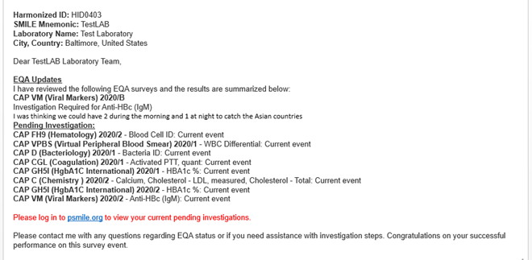

1. All users of the web-based investigation form will need to register on psmile.org and request access to the IR form. Access to the form can be requested by clicking on “Request Access”

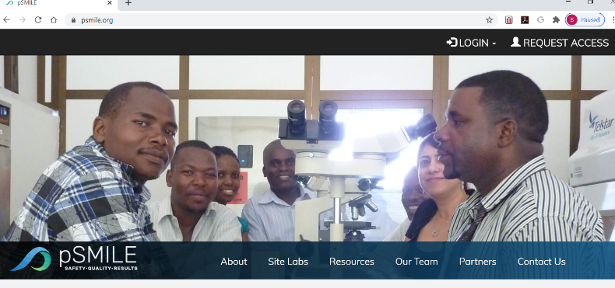

1. On the Request Access to pSMILE form please fill out your name, email and under Affiliation, select *Laboratory Personnel* in the drop-down box. Use the *Desired Lab* drop down box to pick your laboratory. Under *Desired Application*, choose all that you need make sure to pick the Investigation Report. In the In the comment box add any *Comments* as needed.

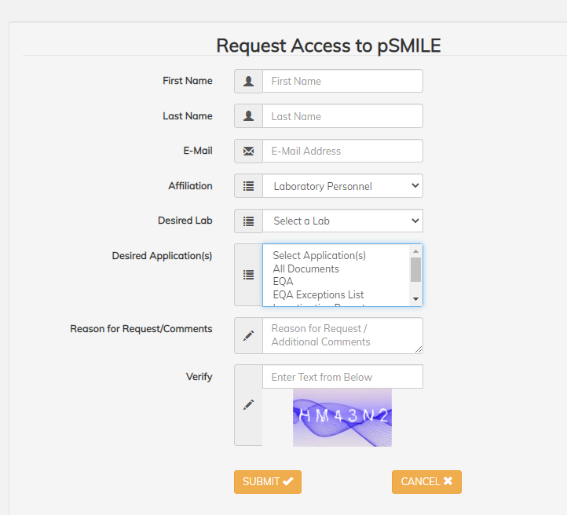

1. To view your laboratory’s investigation report, login to psmile.org. Under Quick Links (bottom right side of the web page) click on “IR for LABS”.



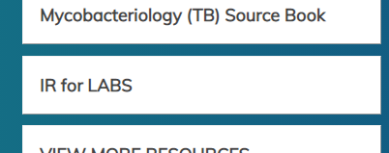

1. Once you click on the link, a list of open investigations are listed under Available IRs for your lab.

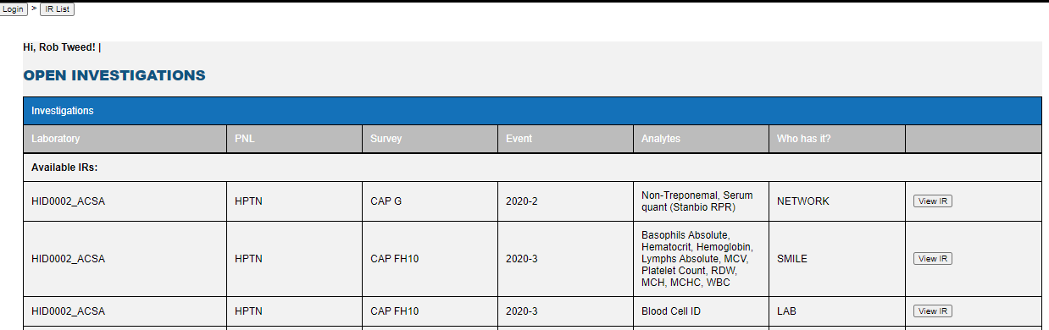

At the bottom of the screen, you will find a list of closed Investigations.



1. The laboratory personnel responsible for completing the investigation can view the Investigation by clicking “View IR” for any investigation that says “LAB” under the “Who has it?” column.

.

1. At the upper right had corner of the investigation form you have the option to print/save the form and guidelines. pSMILE highly suggest printing the form to use as a worksheet to work on the investigation offline. If you click on the underlined red statement – See Recent Changes to this form - you will see a list of all changes and versions of the Investigation Report.

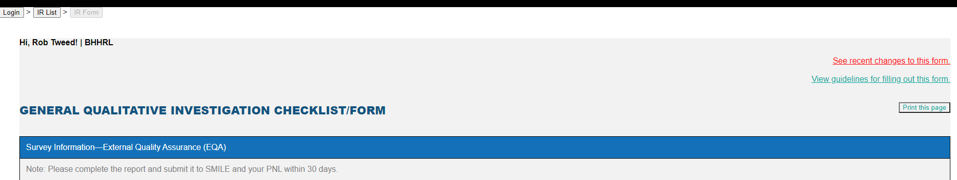

1. The upper section of the form will the following section filled out automatically: Site/Laboratory Name, EQA Provider and Lab ID, Survey, and the Analyzer Name/Model. Be aware that the Analyzer Name/Model comes from the EQA evaluation reports. In cases where there is not an instrument such as, Blood Cell ID this section will be blank and you will need to type in “Not Applicable”.
   * The laboratory will be responsible for fill out: Date Survey Received, Date Analysis Performed, Date Survey Results Submitted, Date Evaluation Available, Investigation performed by and Date.
   * If the survey was not received then click the N/A box and enter comments why survey testing not performed.

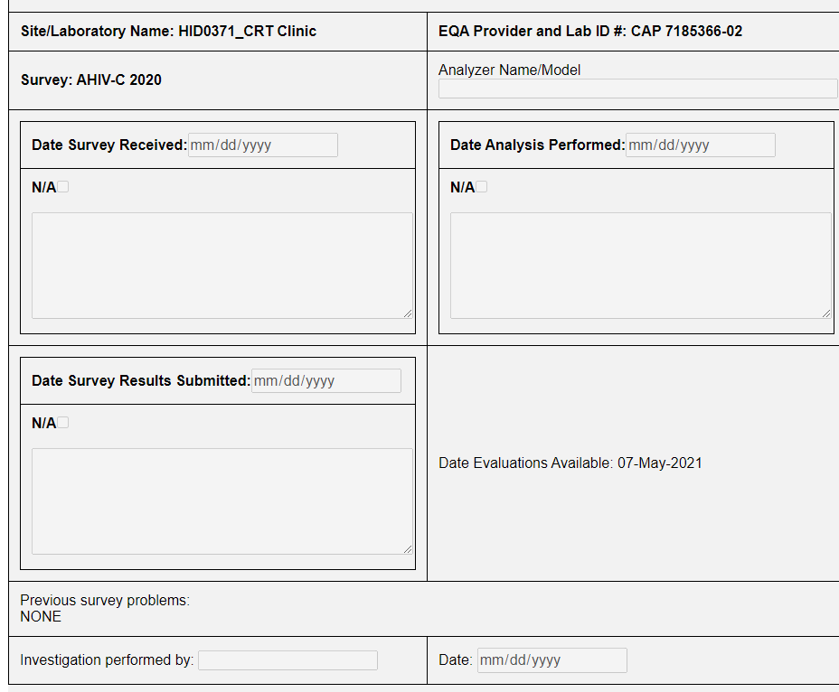

1. Under Unacceptable EQA Panel, the Specimen ID, Analyte, Reported Results and Intended Results/Peer Group are generated automatically.
   * 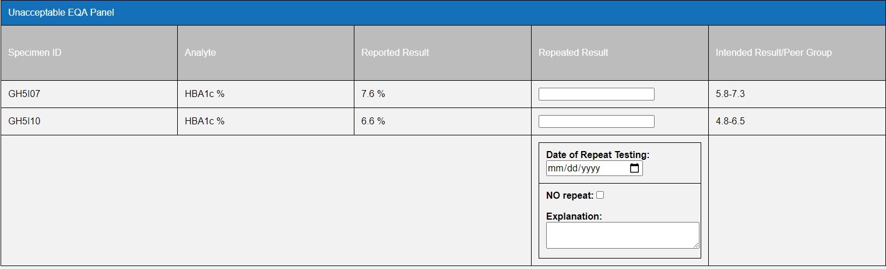The laboratory is responsible for filling out either the Repeated Result and Date of Repeat Testing or No repeat with an explanation as to why EQA is not repeated. In the rare instances, where one sample is repeated and the other sample is not repeated then both section will need to be filled out.
2. If no results have been entered for a survey and the laboratory had not contacted pSMILE the survey will be evaluated as a 0% grade.
3. Instead of multiple lines for the results, only one line per analyte will appear on the investigation Unacceptable EQA Panel.

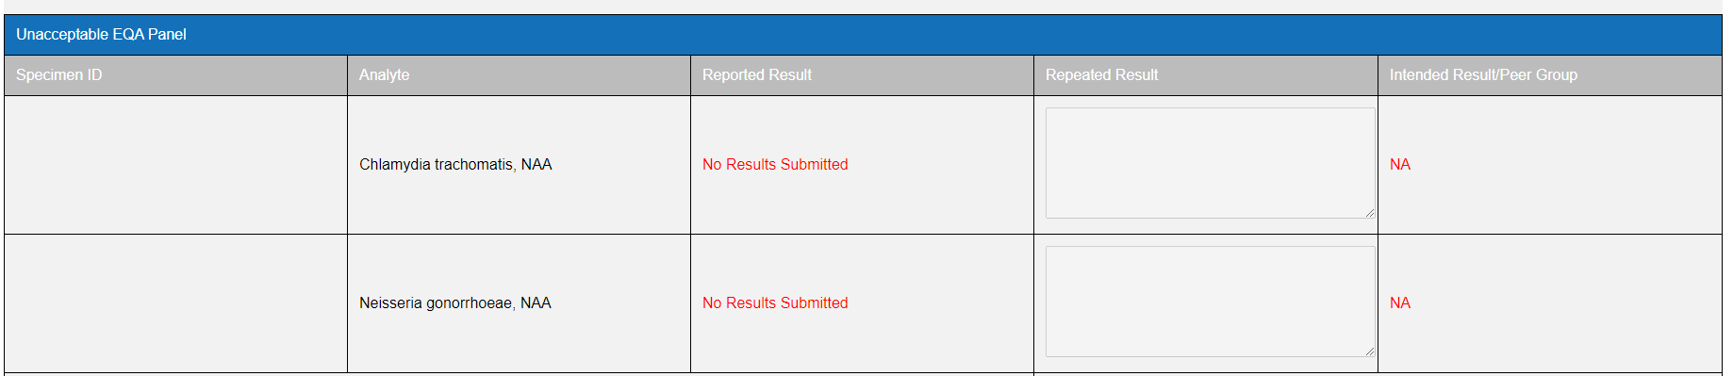

1. If samples can be run then the results are attached to the investigation. In the Repeated Result boxes enter: “See Attachment”. These instructions appear below.
2. If samples cannot be run then enter an explanation in the Explanation box.

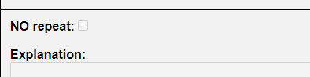

1. If multiple analytes are unacceptable on a survey, it may require separating the investigation into different IRs if the reason for failure is different for each analyte. For example, one analyte failed due to a clerical error and the other failed as a technical error.
2. To split the investigation click on “Enable-Split IR”.

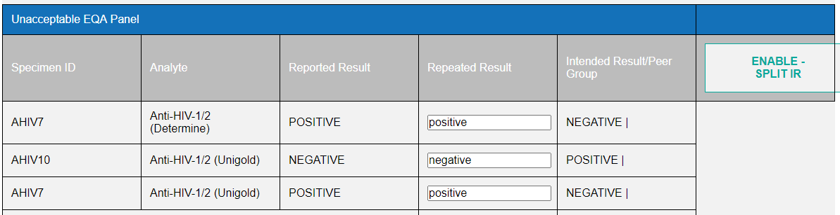

1. 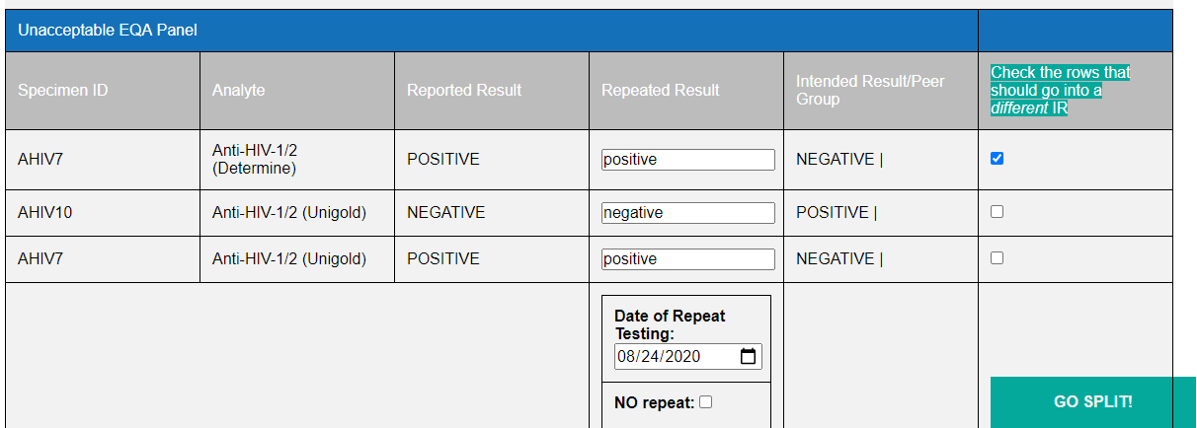Under the “Check the rows that should go into a different IR” column check off the analyte that should be split into a separate investigation. Then click “Go Split”.

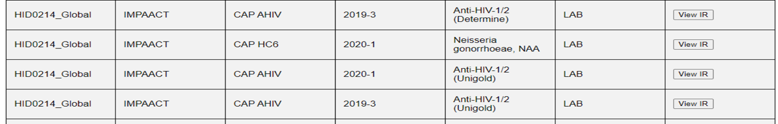When you go back to the main page, Open Investigation the survey will be split into separate investigation forms to work on each analyte separately.

1. All questions under Pre-Analytical, Analytical and Post Analytical require a response. Questions are answered by checking off “Yes”, “No”, or “N/A”. Please add any comment to help explain choice.

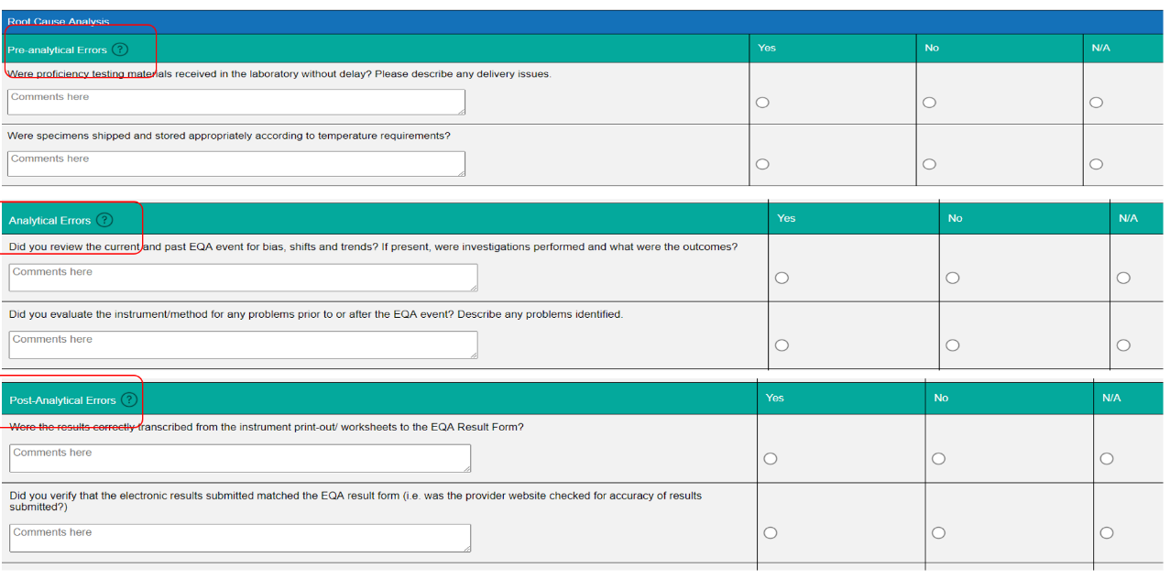

1. The following areas require a response: Investigative Actions and Root Cause, Personnel training and Type of error. If Type of Error is, “Other” an explanation must be given. Study Impact and Future Preventative Measures/Actions are also required fields. If investigation is saved, the comments can be changed but once submitted all comments become permanent. You can add addition comments if the investigation is returned to the laboratory.

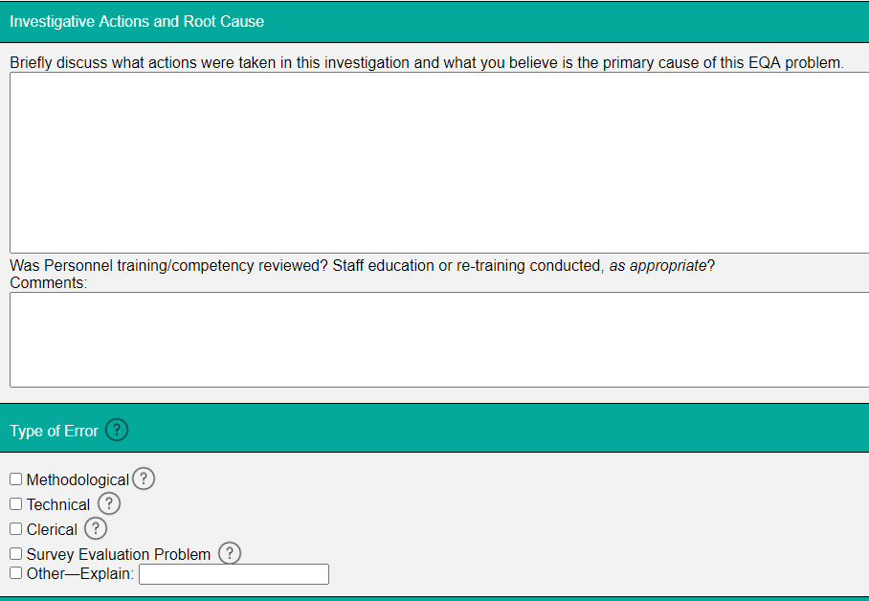

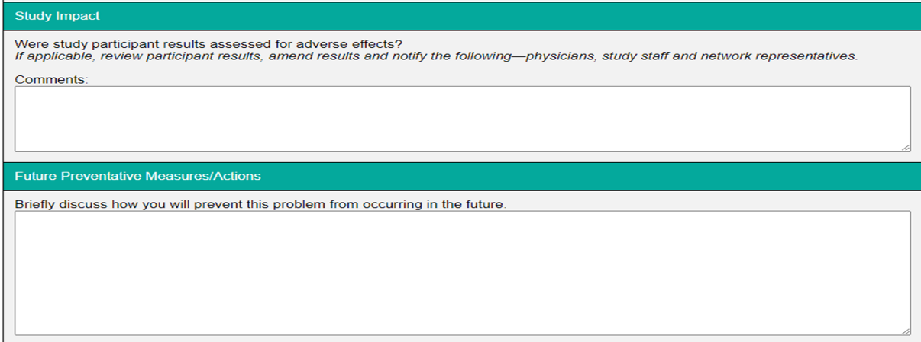

1. Under the “Laboratory Sign Here,” section there is an optional to add any additional comments under “Comments” if needed.
   * If you need to continue editing the investigation later, you can save your progress by clicking on “Save Progress”. It is highly suggested to save your progress periodically especially if your lab experiences internet problems.

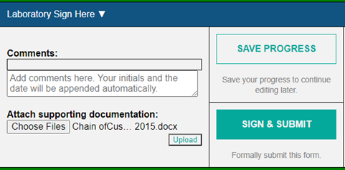

1. If there are any supporting documents to support the investigation, these can be attached in the “Laboratory Sign Here” section under “Attach supporting documentation” and clicking on “Choose Files”.
   * Navigate to where the documents are saved on your computer/server and choose file.
   * Click on “Upload” to attach supporting document.

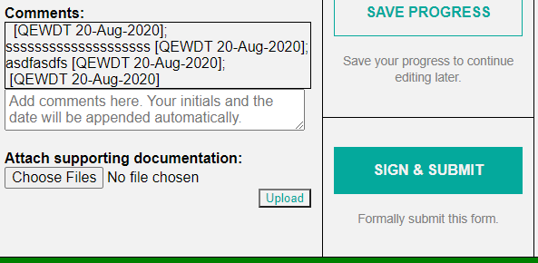

* + It is suggested to open the document to ensure the correct document is uploaded. If the wrong document was uploaded, it can be removed by using the “Remove?” button.

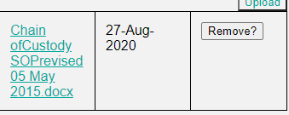

1. Once the investigation is completed click on “Sign & Submit”.

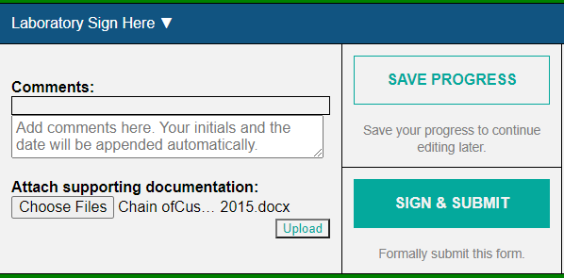

* + If there are any sections incomplete, you will get a pop-up saying, “Please correct the red-bordered error before filing.” Click on “OK” and look through the investigation to find the section outlined in red with the message “This field is required.” Fill out the section and click on “Sign & Submit” once completed.

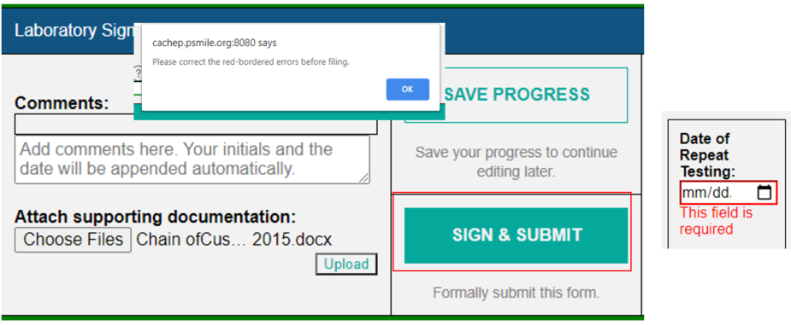

1. Once the laboratory has submitted the investigation an email is sent to the laboratory and pSMILE informing them that the investigation can be reviewed by pSMILE.

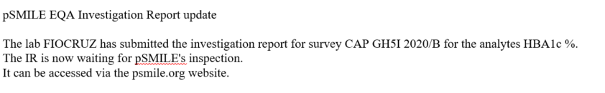

At this point only pSMILE coordinators will be able to approve or reject and add comments to the investigation.

1. pSMILE will either approve or reject the investigation after review. If an investigation is incomplete, pSMILE will reject the investigation and it will be returned to the laboratory. Emails will be sent to inform the laboratory and pSMILE that the investigation was re-opened.

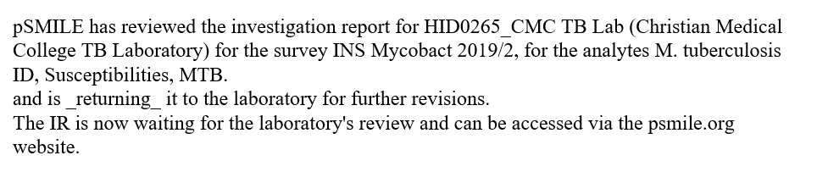

1. The laboratory should return to the investigation on psmile.org and scroll down to the “pSMILE Sign Here” section to read comments made by the pSMILE Coordinator.

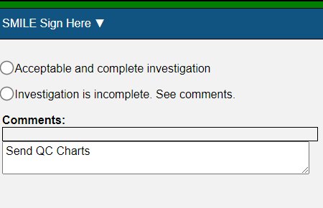

1. Follow steps 14-18 until investigation is complete.
2. After the laboratory, “Signs & Submits” the investigation an email is sent to pSMILE to review and approve the investigation again.
3. Once approved by pSMILE, an email is sent to the all Networks informing them the investigation is now ready for review.



1. The PNL can either approve or reject the investigation. If the PNL rejects the investigation, it will be re-opened and an email will be sent to the laboratory and pSMILE saying that investigation requires further investigation/information from the laboratory. 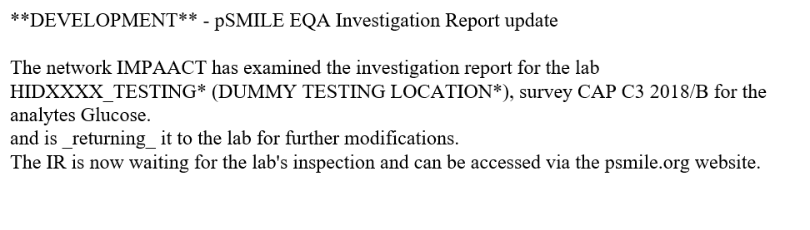
2. The laboratory should return to the investigation on psmile.org and read the Network comments under “Network Sign Here” section.

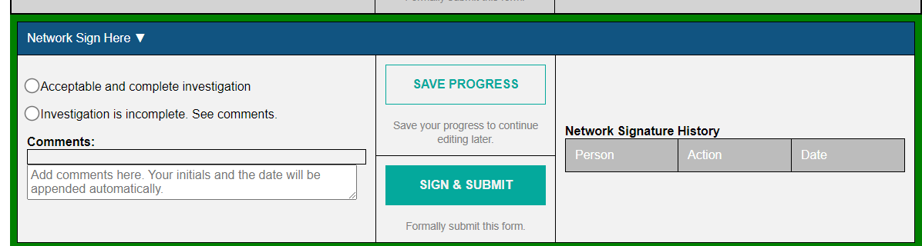

1. Steps 14-24 will be repeated until investigation is complete.
2. Once approved by both pSMILE and the PNL, an email is sent to the DAIDS and pSMILE.

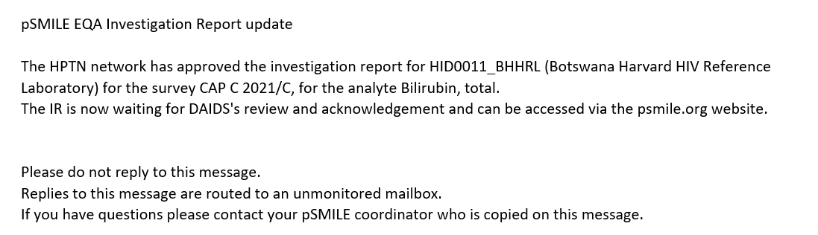

1. Once DAIDS POC acknowledged the investigation an email is sent out to the laboratory and pSMILE coordinators who will closed and combine any uploaded documents. 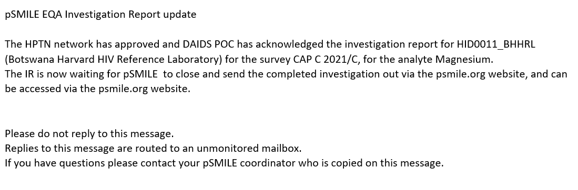
2. All documents will be printed and combined as needed and sent out in an email to the entire laboratory group.
3. There may be rare circumstances that require an investigation to be reopened and the above steps will be repeated.