Instructions for Web-based pSMILE Investigation Form for Network Personnel and DAIDS: Review and approval

The purpose of this document is to explain the steps to navigate pSMILE’s electronic investigation report.

1. The laboratory and network(s) are notified of any required investigations by the monthly EQA/Action Plan email.
2. To view the investigation report, networks sign onto psmile.org and click on “IR for Network” in the Quick Links.

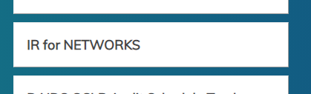

In this first section, the network personnel will see a list of laboratory investigations for which they are PNL. These are the investigations that the PNL needs to review and approve.

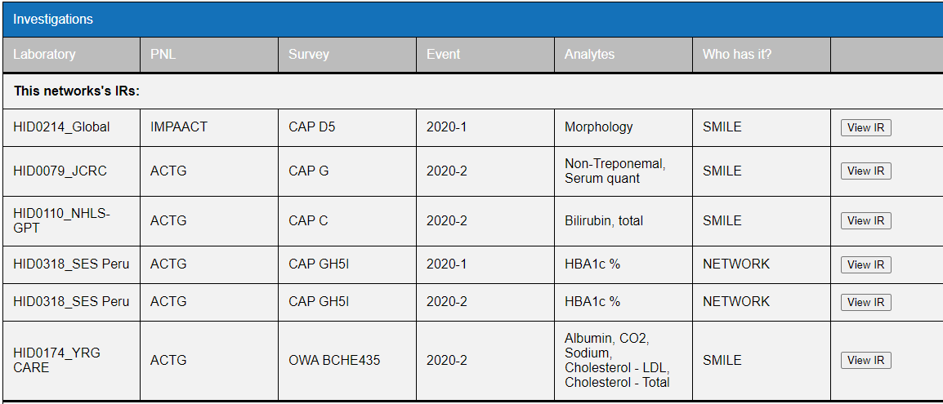

The section below are all the other open investigations.

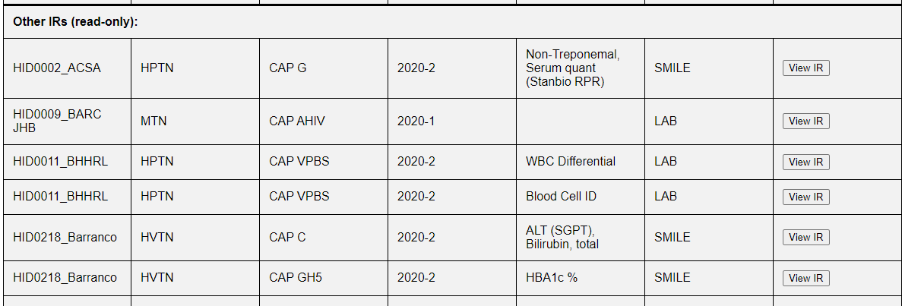

If there are any supporting documents attached to the investigation, these can be viewed by going to the “Laboratory Sign Here” section and clicking on any of the uploaded documents. If the laboratory had not resulted the survey and has a grade of 0% any repeated results will be attached.

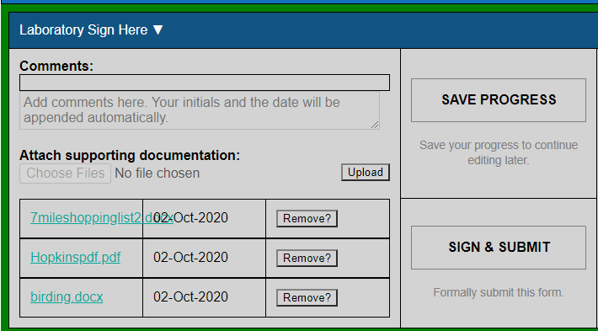

**\*\*\* It is important for all network personnel to carefully review the information submitted by the laboratory to ensure that all protocol analytes investigations are complete. \*\*\***

1. Once the laboratory has submitted the investigation an email will be sent to the laboratory and pSMILE informing them that the investigation can be reviewed by pSMILE.

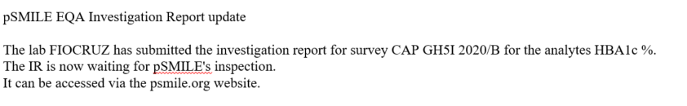

At this point only pSMILE coordinators will be able to approve or reject and add comments to the investigation, but all networks will be able to view the report.

1. pSMILE will either approve or reject the investigation after review. If an investigation is incomplete, pSMILE will reject the investigation and it will be returned to the laboratory. Emails will be sent to inform the laboratory and pSMILE that the investigation was re-opened.

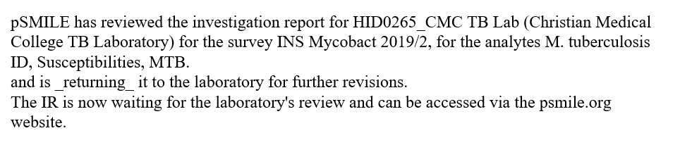

1. Step 4 will be repeated as needed until pSMILE approves the investigation.
2. Once approved by pSMILE, an email will be sent to inform the all the networks that the investigation is now ready for review. The email is also sent to the lab and pSMILE Coordinators.



1. The PNL can either approve or reject the investigation. If rejected, comments should be added for the laboratory to perform additional steps.

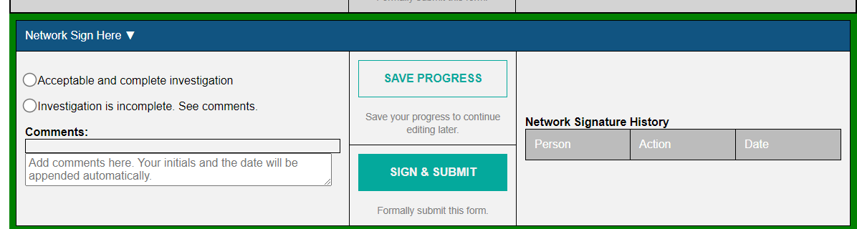

1. If the PNL rejects the investigation, it will be re-opened and an email will be sent to the laboratory, pSMILE and PNL network saying that investigation requires further investigation/information from the laboratory.

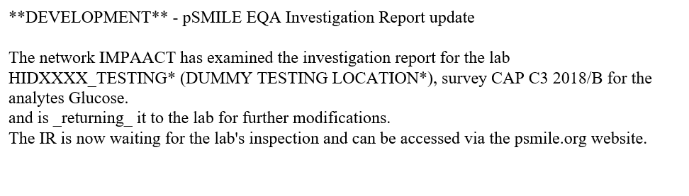

1. Steps 3-8 may be repeated as needed.
2. Once approved by both pSMILE and the PNL an email is sent to the DAIDS POC for acknowledgement.

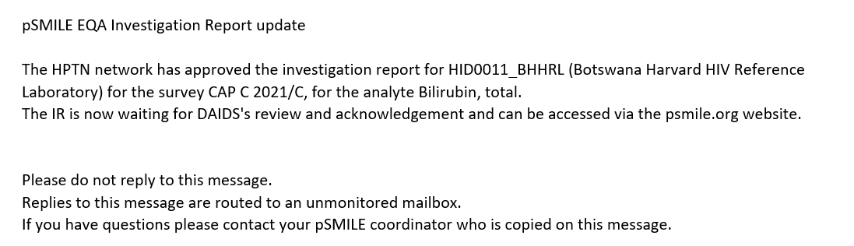

1. DAIDS will log onto psmile.org and in the Quick Links section click on **IR for Networks** tab.



1. If there are any investigations requiring DAIDS acknowledgement they will appear in the top section and on the right had side under the **Who has it?** Column will say DAIDS.

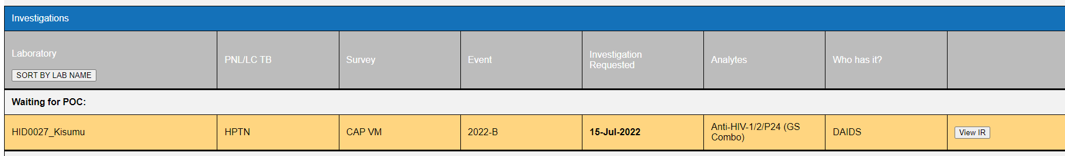

1. Click on **View IR** and go to the **POC sign Here** section.

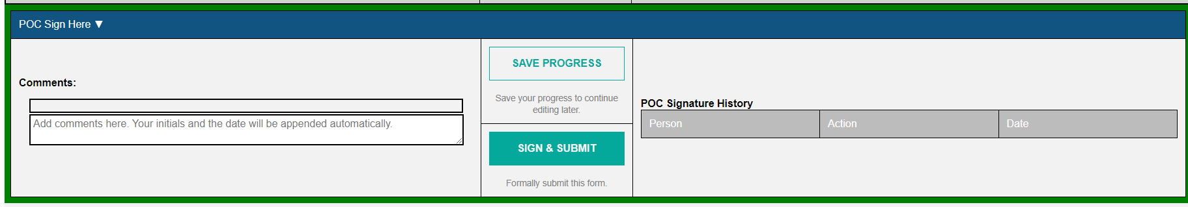

1. Click on **Sign and Submit.**
2. Once DAIDS POC acknowledged the investigation an email is sent out to the laboratory and pSMILE coordinators who will closed and combine any uploaded documents.

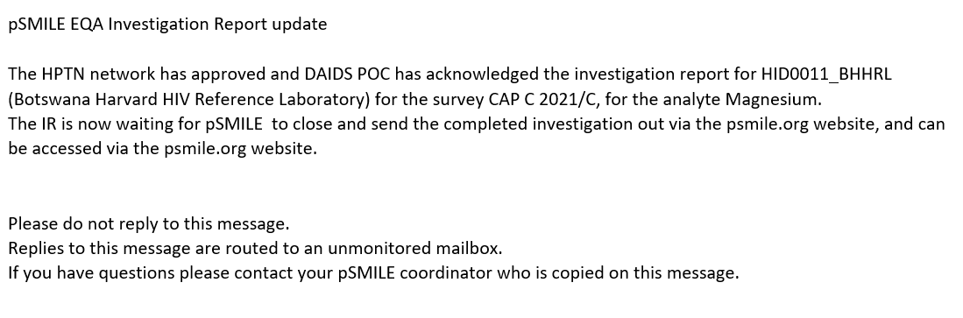

1. All documents will be printed and combined as needed and sent out in an email to the entire laboratory group.
2. There may be rare circumstances that require an investigation to be reopened and the above steps will be repeated.